Practical - 13
PHP JSON API and AJAX/Fetch-Based CRUD without Page Reload
Problem Definition: Create simple PHP JSON API endpoints for events or students and consume them using Fetch API. Perform list, add, update, and delete operations asynchronously without full page reload.

A. Theory
1. What is a JSON API?
Answer: A JSON API allows a frontend and backend to exchange structured data in JSON format.
2. What is Fetch API?
Answer: Fetch is a JavaScript interface for making asynchronous HTTP requests and handling responses using promises.
3. What does CRUD without page reload mean?
Answer: JavaScript sends a request to PHP, receives JSON, and updates only the relevant part of the page instead of reloading the whole document.
4. Why use HTTP status codes and error handling?
Answer: Status codes communicate outcomes consistently, while structured error handling helps the frontend display useful messages and diagnose failures.

B. Implementation / Procedure
1. API endpoint
Create a PHP endpoint that sets Content-Type: application/json, checks the HTTP method/action, and returns JSON for every outcome.
2. GET list
Connect to MySQL using MySQLi and return a list of students or events as JSON.
3. Create/update/delete
Read JSON request bodies using json_decode(file_get_contents('php://input'), true) when appropriate. Validate values and use prepared INSERT, UPDATE, and DELETE statements.
4. Frontend fetch
Use fetch() with the appropriate method, headers, and JSON.stringify() body. Check response.ok and parse response.json().
5. Update interface
Render returned records into the page and show loading, success, empty, and error states. Avoid inserting untrusted data with unsafe innerHTML.
6. Test API
Use browser DevTools Network tab to verify request method, payload, status code, response JSON, and that the page did not reload.

C. Test Cases
Test Case | Input / Action | Expected Result
List records | Open page | GET returns valid JSON and list renders
Add record | Submit valid data | POST succeeds and list updates without reload
Invalid data | Submit missing/invalid fields | API returns an error and no row is inserted
Update record | Edit a record | Database and UI show updated data
Delete record | Delete a record | Record disappears without full-page reload

D. Key Questions / Analysis / Interpretation
1. Do PHP endpoints return valid JSON responses?
Answer: The endpoint sets an application/json content type and returns a consistent JSON object, including success status, message, and data where applicable.
2. Are GET and POST requests handled properly?
Answer: GET is used to retrieve data; POST can create records. Update and delete may use POST with an explicit action or appropriate HTTP methods, with server-side validation.
3. Are loading, success, and error states shown on the frontend?
Answer: The interface shows loading feedback during a request, confirms successful operations, and displays an error if the request or server fails.
4. Is input validation performed before database operations?
Answer: The PHP endpoint validates every field and identifier before running a prepared database query. Frontend validation is not sufficient on its own.

Evidence of Work (Screenshot)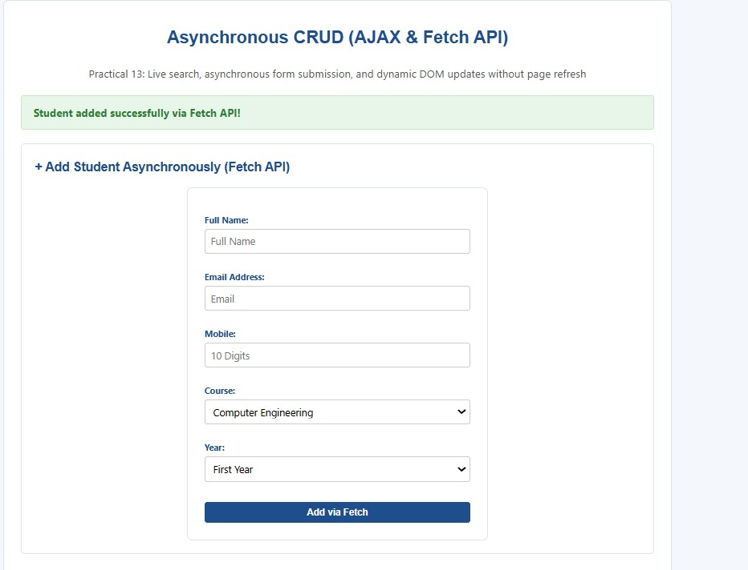
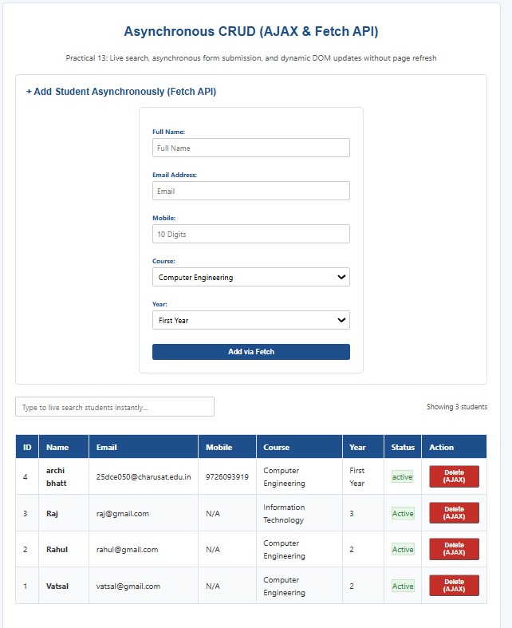
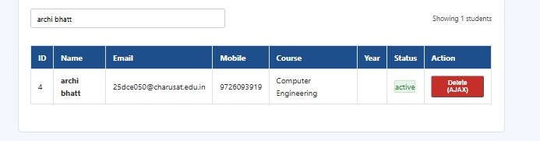

N. GitHub Repository Link
https://github.com/archibhatt091601/studenthub-ortal

